**Assignment No: 02**



Fall 2023

CSE-423 Web Engineering

Submitted by: **Ashfaq Ahmad**

Registration No: **19PWCSE1795**

Class Section: **B**

“On my honor, as student of University of Engineering and Technology, I have neither given nor received unauthorized assistance on this academic work.”

Student Signature: ______________

Submitted to:

**Eng. Madeha Mushtaq**

**March** 31, 2023

**Department of Computer Systems Engineering**

**University of Engineering and Technology, Peshawar**

**Task01:**

Develop a JavaScript program to move two small squares inside one big square in a

random manner. User should be able to start and stop this animation using buttonbased events. Use setTimeout() and setInterval().

**Useful tip**: Math.floor(Math.random() * Math.floor(max)) will give you a random number that is less than max value.

**HTML Code:**

<!DOCTYPE html>

<html lang="en">

<head>

    <meta charset="UTF-8">

    <meta http-equiv="X-UA-Compatible" content="IE=edge">

    <meta name="viewport" content="width=device-width, initial-scale=1.0">

    <title>Boxes motion</title>

    <link rel="stylesheet" href="css_code.css">

</head>

<body>

    <h1>Ashfaq Ahmad</h1>

    <br>

    <div class="container" id="bigsquare">

        <div class="sq1" id="ss1"></div>

        <div class="sq2" id="ss2"></div>

    </div>

    <button id="start">Start</button>

    <button id="stop">Stop</button>

    <button id="reset">Reset</button>

    <script src="javscript_code.js"></script>

</body>

</html>

**CSS Code:**

.container{

    width: 200px;

    height: 200px;

    background-color: lightgreen;

    border: 2px solid red;

}

.sq1{

    background-color:blue;

}

.sq2{

    background-color: red;

}

.sq1,.sq2{

    width: 40px;

    height: 40px;

}

**JavaScript Code:**

let bigSquare = document.getElementById('bigsquare');

let smallSq1 = document.getElementById('ss1');

let smallSq2 = document.getElementById('ss2');

let start = document.getElementById('start');

let stp = document.getElementById('stop');

let reset = document.getElementById('reset');

start.addEventListener('click', startanimation);

stp.addEventListener('click', stopanimation);

reset.addEventListener('click', resetsquares);

function movesquares() {

    const x1 = Math.floor(Math.random() * (bigSquare.clientWidth - smallSq1.clientWidth));  //avaialable 150px to right from it's original position.

    const y1 = Math.floor(Math.random() * (bigSquare.clientHeight - smallSq1.clientHeight));//avaialable 150px to bottom from it's original position.

    smallSq1.style.transform = `translate(${x1}px, ${y1}px)`;

    const x2 = Math.floor(Math.random() * (bigSquare.clientWidth - smallSq2.clientWidth));//avaialable 150px to right from it's original position.

    const y2 = Math.floor(Math.random() * (bigSquare.clientHeight - 2 * smallSq2.clientHeight));//avaialable 100px to bottom from it's original position.

    smallSq2.style.transform = `translate(${x2}px, ${y2}px)`;

}

let returnId;

function startanimation() {

    returnId = setInterval(movesquares, 1000)

}

function stopanimation() {

    clearInterval(returnId);

}

function resetsquares() {

    clearInterval(returnId);

    smallSq1.style.transform = `translate(${0}px,${0}px)`;//move 0px from its original position.

    smallSq2.style.transform = `translate(${0}px,${0}px)`;

}

**Result:**

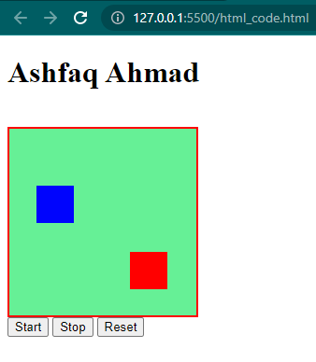

**Task02:**

Write a code using jQuery that will automatically adjust the font size as we increase

or decrease the window width. Hint: Use width(), resize().

**HTML Code:**

<!DOCTYPE html>

<html lang="en">

<head>

    <meta charset="UTF-8">

    <meta http-equiv="X-UA-Compatible" content="IE=edge">

    <meta name="viewport" content="width=device-width, initial-scale=1.0">

    <title>Task02</title>

    <link rel="stylesheet" href="Task02.css">

    <script src="https://ajax.googleapis.com/ajax/libs/jquery/3.6.3/jquery.min.js"></script>

    <script src="task02.js"></script>

</head>

<body>

    <p id="size">

        Lorem ipsum dolor sit amet consectetur adipisicing elit. Labore porro ipsum, aperiam praesentium qui, aliquid

        ipsam cumque doloribus dolores magni possimus laudantium culpa error id mollitia, architecto repellendus nam

        dignissimos.

    </p>

    </script>

</body>

</html>

**JQuery Code:**

$(document).ready(function(){

    $(window).on('resize',function(){

        const windowwidth=$(window).width();

        const fontsize=windowwidth/20;

        $('#size').css('font-size',fontsize +'px');

    });

})

**Result:**

**Window size:** 350px x 569px

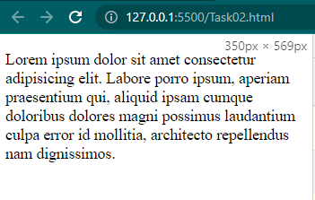

**Window size: 721px x 569px**

